*Highlighted part is either note to internal team or content that needs to be replaced with correct values e.g. email addresses, dates, etc.*

Below is a complete Consent Policy draft for SproutSong / SproutMentors, prepared for internal team review, DPDP compliance tracking, and later website publication.

It covers how consent is collected, stored, managed, withdrawn, audited, and linked to different user types such as children/students, parents/guardians, schools, teachers, mentors, educators, and public visitors.

---

SproutSong / SproutMentors

Consent Policy

Internal Review Draft for Compliance Tracking

Document Name: Consent Policy
Platform: SproutSong / SproutMentors
Version: v1.0 Draft
Prepared For: Internal Review, DPDP Compliance Tracking, Website Publication
Status: Draft — Legal Review Pending
Effective Date: To be added
Last Updated: To be added
Privacy Contact: privacy@sproutsong.com
Support Contact: support@sproutsong.com

---

Internal Review Checklist

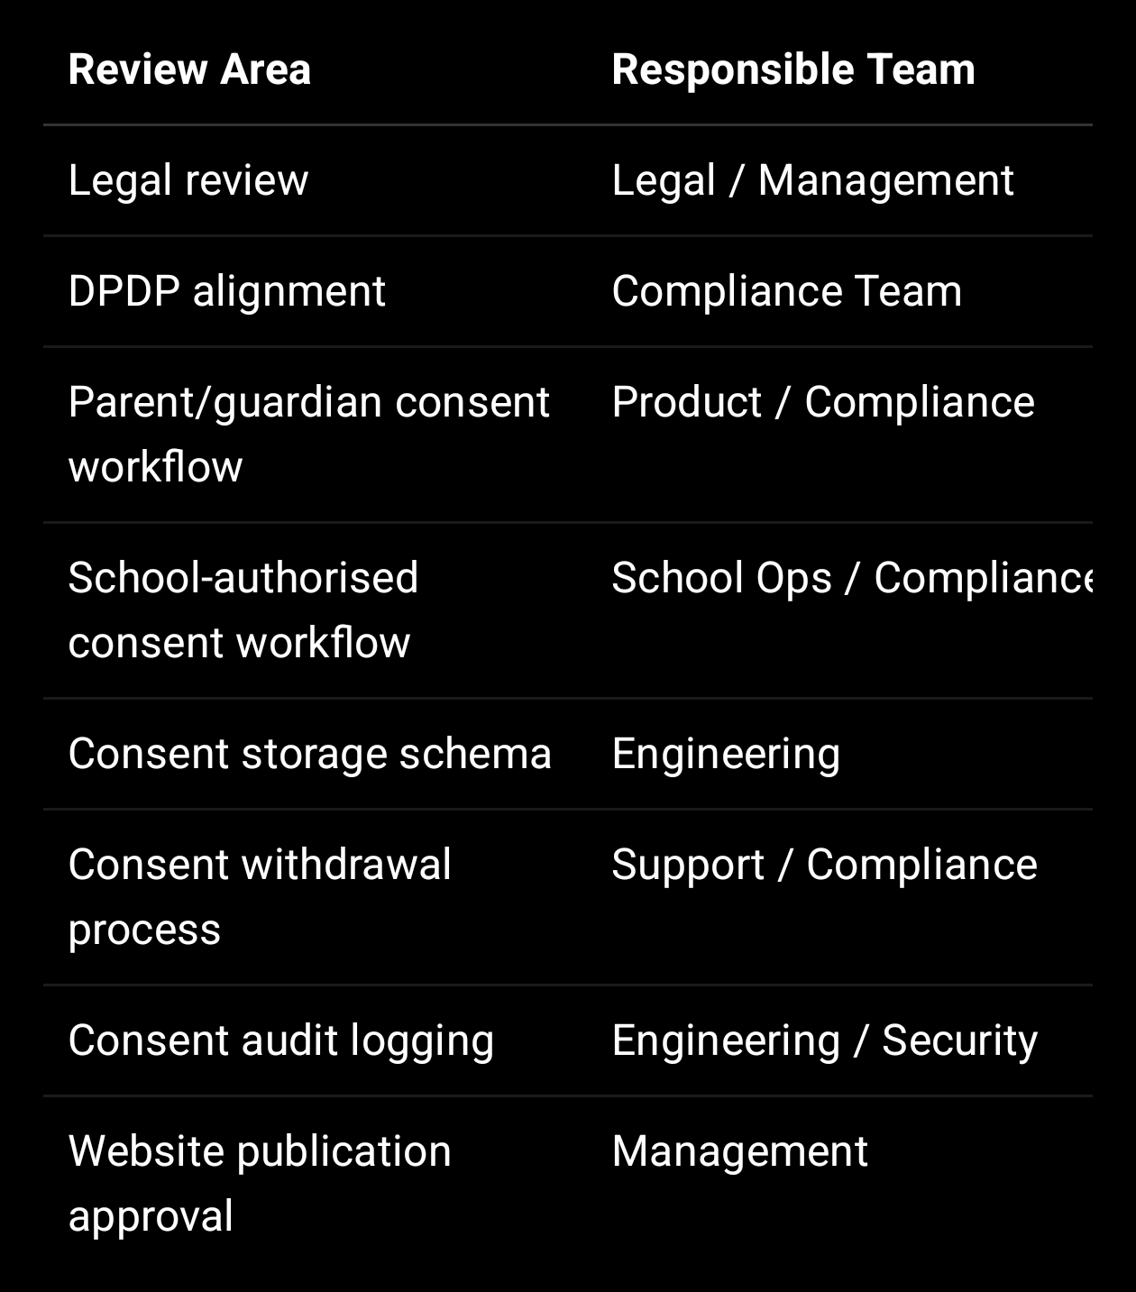

---

1. Purpose of This Policy

This Consent Policy explains how SproutSong / SproutMentors collects, records, stores, verifies, manages, and withdraws consent for processing personal data.

SproutSong / SproutMentors processes personal data of students, parents, teachers, mentors, counsellors, educators, school administrators, schools, and visitors. Since the platform works with schools and children, consent management is a major compliance and trust requirement.

This policy is designed to ensure that:

1. Users understand what data is collected and why.

2. Consent is collected clearly and actively.

3. Children’s data is processed with parent/guardian or school-authorised consent where required.

4. Consent proof is stored with timestamp, policy version, user details, IP address, and user agent.

5. Users can withdraw consent where applicable.

6. Consent records can be audited later.

Your internal DPDP/security report states that every important form should include purpose text, consent checkbox, parent/guardian consent for minors, Privacy Policy link, Terms link, data usage explanation, document upload warning, withdrawal/deletion option, and a clear privacy contact email.

---

2. Scope of This Policy

This policy applies to all SproutSong / SproutMentors:

Websites
Web applications
School portals
Student portals
Parent portals
Teacher portals
Mentor/counsellor portals
School admin dashboards
Public forms
Counselling forms
AI report features
Document upload features
Communication systems
Analytics/cookie systems, where applicable
Backend APIs and databases

It applies to these user types:

Students
Children/minors
Parents/lawful guardians
Schools/institutions
Teachers
Mentors
Counsellors
Educators
Principals/school admins
Public visitors
SproutSong internal users

---

3. Consent Principles

SproutSong / SproutMentors follows these consent principles.

3.1 Clear Purpose

Before collecting data, the form/module should explain:

What data is collected
Why it is collected
Who can access it
How long it is kept
How consent can be withdrawn

Your internal guide says the team’s goal is to answer: what data is collected, why it is collected, where it is stored, who can access it, and how long it is kept.

3.2 Active Agreement

Consent must be given by a clear affirmative action.

Allowed:

User manually checks an unchecked checkbox.
User verifies OTP/email link.
School authorised representative signs/accepts declaration.
Parent/guardian confirms consent with relationship details.

Not allowed:

Pre-checked checkbox.
Consent hidden inside long text without clear label.
Consent assumed from silence.
Consent bundled with optional marketing.

3.3 Separate Consent for Separate Purposes

Some processing requires separate consent.

Examples:

Student registration consent
Document upload consent
Counselling consent
AI-assisted analysis consent
Communication consent
Marketing/newsletter consent
Photo/media publication consent
Teacher sensitive HR data consent

AI-assisted analysis should have separate consent because your internal AI checklist specifically marks consent as required for AI-assisted analysis and human review as required for counselling/career guidance.

3.4 Verifiable Consent for Children

For students under 18, consent should be given or confirmed by:

Parent
Lawful guardian
Authorised school representative, where valid under school arrangement

For sensitive workflows, a simple checkbox should not be treated as sufficient proof. The parent/guardian should actively confirm their identity or relationship where possible. Your form security guide says DPDP obligations require verifiable parental/guardian consent for students under 18 and recommends storing timestamp, IP, and parent contact used.

3.5 Consent Proof Must Be Stored

Every important consent should be stored with:

Consent type
Consent text
Consent text version
Privacy Policy version
Terms version
Checkbox status
Timestamp
User/parent/school details
IP address
User agent
Source form/module
Related student/school/document/report ID
Withdrawal status

Your DPDP/security report recommends adding consent timestamp, consent version, consent source, and consent accepted by for student records.

---

4. Consent Types

SproutSong / SproutMentors should maintain the following consent types.

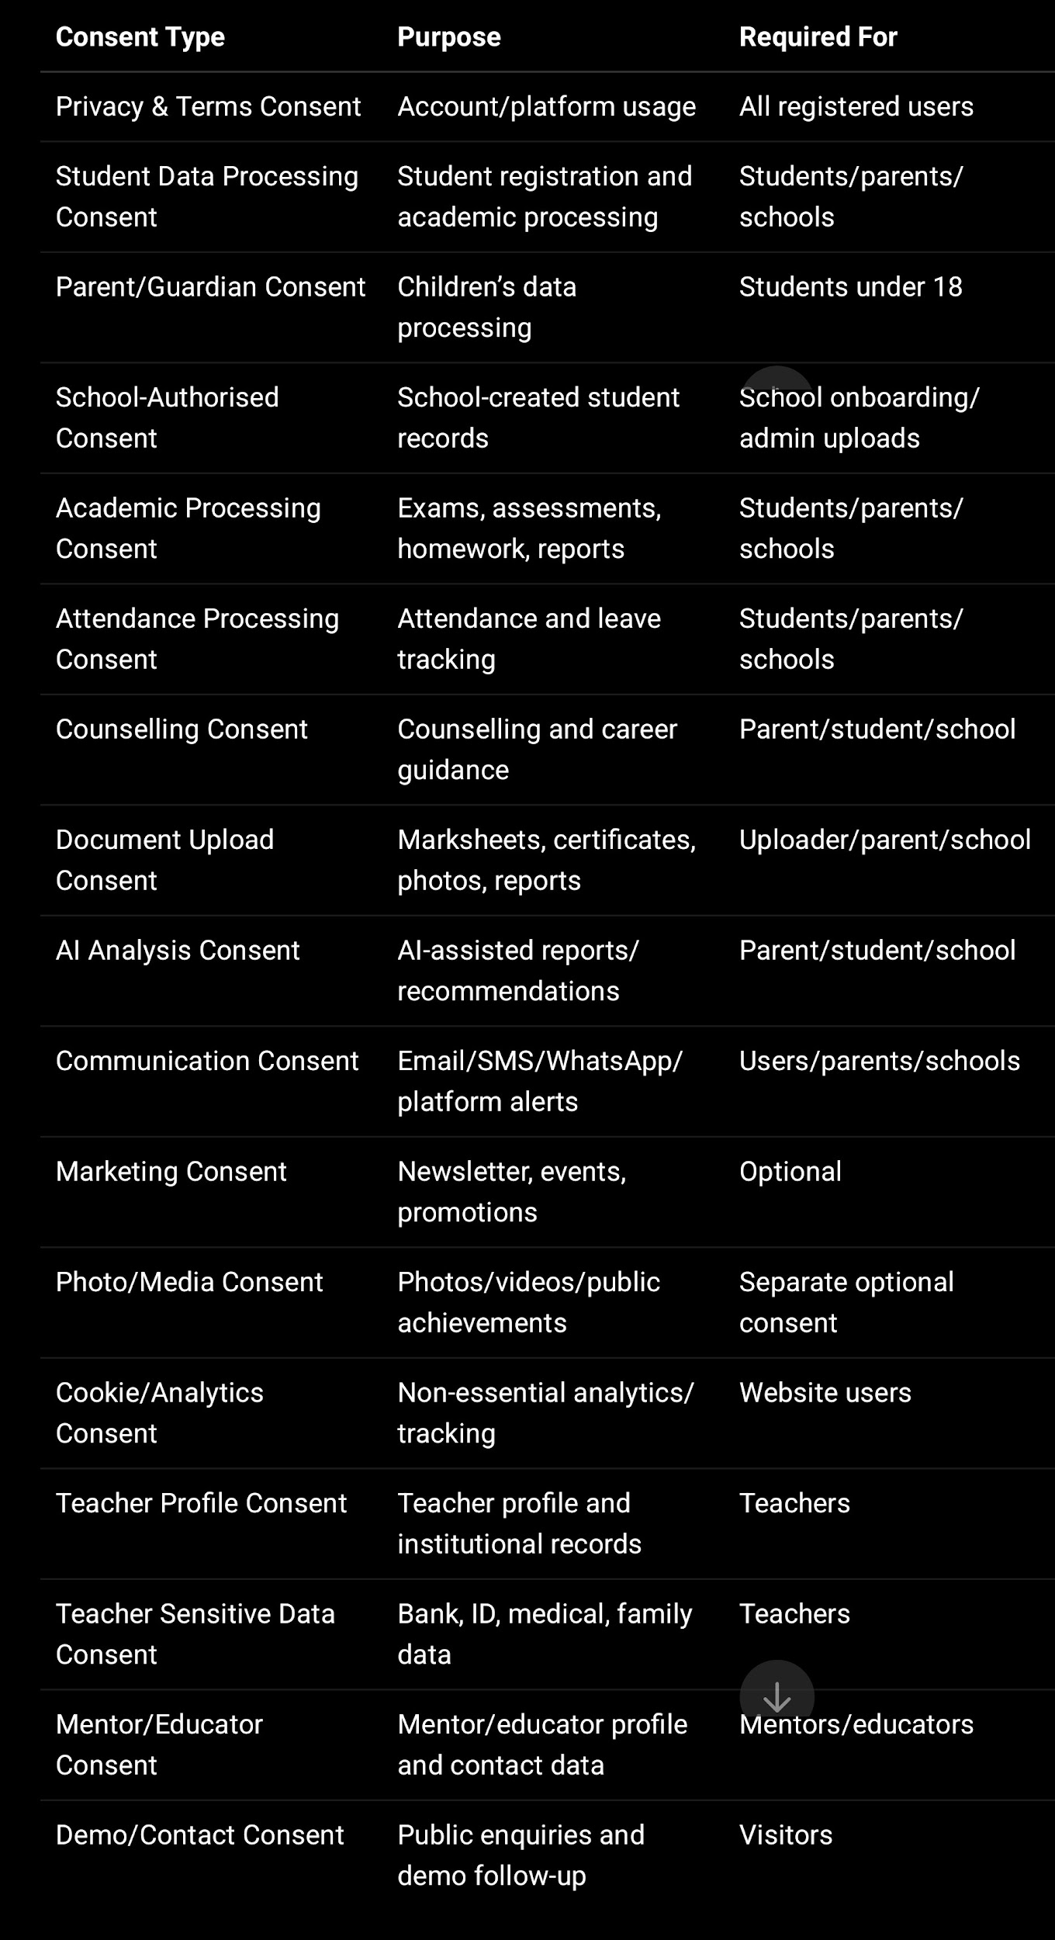

---

5. Consent Collection by User Type

5.1 Children / Students

Students may provide acknowledgement where appropriate, but for students under 18, parent/guardian or school-authorised consent is required for processing children’s personal data.

Consent required for students

Student registration
Academic processing
Attendance
Homework/assignment/project processing
Exam/assessment/report processing
Counselling
Document upload
AI-assisted report generation
Communication
Photo/media use, if applicable

Student-facing acknowledgement text

I understand that my academic information, assignments, reports, attendance, and counselling inputs may be used by my school and SproutSong / SproutMentors to support my learning, guidance, and school activities.

I understand that recommendations are for educational support and should be reviewed with my parent, teacher, counsellor, or school.

Parent/guardian consent for minor students

I confirm that I am the parent or lawful guardian of the student named in this form.

I consent to SproutSong / SproutMentors collecting, storing, and processing the student’s personal, academic, attendance, document, counselling, and learning-related data for educational, academic, counselling, reporting, communication, and student support purposes.

I understand that I may request access, correction, withdrawal of consent, or deletion by contacting privacy@sproutsong.com.

Checkbox:

☐ I confirm that I am the parent/lawful guardian and consent to processing the student’s data.

---

5.2 Parents / Guardians

Parents/guardians provide consent for:

Parent account creation
Parent-child linking
Student data processing
Communication
Reports
Counselling
Document upload
AI-assisted analysis
Photo/media use, if applicable

Parent account consent text

I consent to SproutSong / SproutMentors collecting and processing my personal and contact information to create my parent/guardian account, link me with my child’s school records, provide access to my child’s academic reports, attendance, homework, communication, and school updates.

I understand that my access is limited to my linked child/children only.

Checkbox:

☐ I consent to creating my parent/guardian account and linking it with my child’s records.

---

5.3 Schools / Institutions

Schools may share or upload student data where they are authorised to do so.

School consent or declaration is required for:

School onboarding
Bulk student upload
Student profile creation
Academic record upload
Attendance import
Report generation
Teacher/staff account creation
School-level analytics
AI-assisted school dashboards
School communication

School-authorised consent text

I confirm that I am authorised by the school/institution to submit this information to SproutSong / SproutMentors.

I confirm that the school has authority to share student, parent, teacher, staff, academic, attendance, counselling, document, and operational data with SproutSong / SproutMentors for agreed educational, academic, administrative, reporting, communication, counselling, and student support purposes.

Where a student is below 18 years of age, I confirm that the school has obtained parent/lawful guardian consent where required or has lawful authority under applicable school policies and law to share such data for educational purposes.

Checkbox:

☐ I confirm school authorisation and consent basis for sharing this data with SproutSong / SproutMentors.

Your DPA-style workflow should align with the internal guidance that schools must verify data necessity, consent, child data involvement, school-level isolation, role permissions, and retention/deletion.

---

5.4 Teachers

Teachers provide consent for:

Teacher account creation
Teacher profile processing
Class allocation
Academic administration
Communication
Professional records
Sensitive HR fields where applicable

Teacher profile consent text

I consent to SproutSong / SproutMentors collecting, storing, and processing my teacher profile information for employment, institutional records, academic administration, class allocation, timetable management, communication, and school operations.

I understand that sensitive information such as identity documents, bank details, family details, and medical information will be used only for authorised HR, administrative, compliance, payroll, or institutional purposes and will be restricted to authorised users only.

Checkbox:

☐ I consent to processing my teacher profile information for school and platform operations.

Separate sensitive consent checkboxes:

☐ I consent to processing my identity/KYC information for verification and institutional compliance purposes.

☐ I consent to processing my bank/payment information for payroll, reimbursement, or authorised financial administration purposes.

☐ I consent to processing my medical/emergency information only for safety, emergency, and authorised HR purposes.

---

5.5 Mentors / Counsellors / Educators

Mentor/counsellor consent text

I consent to SproutSong / SproutMentors collecting and processing my mentor/counsellor profile, qualification, contact, experience, availability, and professional information for profile creation, student assignment, counselling operations, communication, and service delivery.

I understand that my profile may be visible to authorised school users, assigned students/parents, and platform administrators depending on the platform settings.

Checkbox:

☐ I consent to processing my mentor/counsellor profile for counselling and student support services.

---

5.6 Public Visitors

Applies to:

Demo request form
Contact form
AI workshop form
Newsletter form
General enquiry form

Demo request consent text

By submitting this form, I confirm that the information provided is accurate and I consent to SproutSong processing this data to schedule a product demonstration, contact me for follow-up, and assess fit for SproutSong’s services.

I understand that I can request deletion by emailing privacy@sproutsong.com and that I can withdraw this consent at any time.

Checkbox:

☐ I consent to SproutSong contacting me for demo scheduling and follow-up communication.

Your forms guide specifically states demo/contact consent should be unchecked by default, required, should link to the Privacy Policy, should be purpose-limited to demo scheduling/follow-up, and should store consentGiven, consentTimestamp, and consentIP.

---

6. Consent Collection by Module / Form

6.1 Student Registration

Required consent:

Parent/guardian consent if minor
School-authorised declaration if school creates the record
Privacy Policy and Terms agreement
Student data processing consent

Minimum checkbox:

☐ I confirm that I am the parent/lawful guardian or authorised school representative and consent to processing the student’s data for educational, academic, attendance, reporting, communication, and student support purposes.

---

6.2 Counselling Form

Required consent:

Parent/guardian consent
Counselling consent
Document upload consent
AI consent if AI report is generated
Student acknowledgement where appropriate

Your form guide marks counselling as highest risk and requires verifiable parental consent for minors.

Consent text:

I consent to SproutSong / SproutMentors processing the student’s personal information, academic records, uploaded documents, interests, preferences, and counselling-related information for educational counselling, career guidance, academic analysis, and report generation purposes only.

---

6.3 Document Upload

Required for:

Marksheets
Certificates
Reports
Profile photos
Teacher documents
Counselling documents

Consent text:

I understand that uploaded documents such as marksheets, certificates, reports, photographs, or identity/qualification documents may contain personal data.

I confirm that I am authorised to upload these documents and consent to SproutSong / SproutMentors using them only for the stated educational, counselling, verification, or administrative purpose.

Your internal guide requires a document upload warning and says documents such as marksheets must only be used for stated educational/counselling purposes.

---

6.4 AI Report Generation

Required consent:

AI-assisted educational analysis consent
Parent/guardian consent for minors
Human review acknowledgement

Consent text:

I understand that SproutSong / SproutMentors may use AI-assisted or technology-assisted analysis to generate educational insights, career guidance, learning recommendations, counselling summaries, academic reports, and parent-ready summaries.

I consent to the use of the student’s academic, counselling, attendance, interest, and learning-related data for AI-assisted educational support purposes only.

I understand that AI output is assistive and not a final decision, and that AI-generated recommendations must be reviewed by a teacher, counsellor, parent, or authorised school representative before final use.

Checkbox:

☐ I consent to AI-assisted educational analysis and report generation.

---

6.5 Attendance

Usually collected as part of onboarding consent.

Consent text:

I understand that SproutSong / SproutMentors may process student attendance records, absence status, leave records, and limited absence reason categories for school administration, academic participation tracking, parent communication, safety, and reporting purposes.

Absence reasons should be limited to necessary information only.

---

6.6 Reports / Exams / Assessments

Consent text:

I consent to SproutSong / SproutMentors processing exam records, assessment responses, marks, grades, teacher remarks, progress indicators, and academic performance data for evaluation, reporting, academic planning, student support, and school administration.

I understand that reports will be shared only with authorised users such as the student, parent/guardian, assigned teachers, school administrators, and authorised mentors/counsellors where applicable.

---

6.7 Photo / Media Consent

This must be separate and optional.

Consent text:

I consent to the use of the student’s photos, videos, name, achievements, or activity participation details for school communication, certificates, internal updates, or approved public communication such as website, brochure, or social media.

I understand that I may withdraw this consent for future use by contacting the school or privacy@sproutsong.com.

Checkbox:

☐ I consent to photo/media use for public communication.

---

6.8 Communication Consent

Consent text:

I consent to SproutSong / SproutMentors and/or the school contacting me through email, SMS, WhatsApp, phone call, or platform notification for academic updates, attendance alerts, reports, counselling communication, school announcements, security alerts, and support-related communication.

Checkbox:

☐ I consent to receiving platform, academic, school, and support communication on my registered contact details.

Marketing/newsletter should be separate and optional.

---

7. How Consent Is Stored

SproutSong should store consent in a dedicated consents collection, not only as consentGiven: true inside the form record.

7.1 Minimum Consent Proof Fields

Every consent record should include:

{
consentType,
agreed: true,
checkboxChecked: true,
agreedAt: Date,
givenByUserId,
givenByName,
givenByType,
relationshipToStudent,
dataPrincipalType,
dataPrincipalId,
studentId,
schoolId,
module,
formName,
relatedRecordType,
relatedRecordId,
consentText,
consentTextHash,
consentVersion,
privacyPolicyVersion,
termsVersion,
ipAddress,
userAgent,
requestId,
source,
verificationMethod,
verificationStatus,
withdrawn: false,
withdrawnAt: null
}

Your DPDP/security report specifically recommends adding parent consent fields such as guardian name, relationship, mobile, email, consent timestamp, and consent IP.

---

8. Recommended Consent Schema

const mongoose = require("mongoose");

const ConsentSchema = new mongoose.Schema(
{
consentId: {
type: String,
required: true,
unique: true,
index: true
},

schoolId: {
type: mongoose.Schema.Types.ObjectId,
ref: "School",
index: true
},

dataPrincipalType: {
type: String,
enum: [
"STUDENT",
"PARENT",
"TEACHER",
"MENTOR",
"COUNSELLOR",
"EDUCATOR",
"SCHOOL_ADMIN",
"VISITOR"
],
required: true,
index: true
},

dataPrincipalId: {
type: mongoose.Schema.Types.ObjectId,
index: true
},

studentId: {
type: mongoose.Schema.Types.ObjectId,
ref: "Student",
index: true
},

givenByType: {
type: String,
enum: [
"SELF",
"PARENT",
"GUARDIAN",
"SCHOOL_AUTHORISED_PERSON",
"TEACHER",
"ADMIN",
"VISITOR"
],
required: true
},

givenByUserId: {
type: mongoose.Schema.Types.ObjectId,
ref: "User",
index: true
},

givenByName: {
type: String,
trim: true
},

givenByEmailHash: String,
givenByMobileHash: String,

relationshipToStudent: {
type: String,
enum: [
"FATHER",
"MOTHER",
"GUARDIAN",
"SCHOOL_ADMIN",
"SELF",
"OTHER",
"NOT_APPLICABLE"
],
default: "NOT_APPLICABLE"
},

isMinor: {
type: Boolean,
default: false
},

consentType: {
type: String,
enum: [
"PRIVACY_TERMS",
"STUDENT_DATA_PROCESSING",
"PARENT_GUARDIAN",
"SCHOOL_AUTHORISED_STUDENT_UPLOAD",
"ACADEMIC_PROCESSING",
"ATTENDANCE_PROCESSING",
"EXAM_ASSESSMENT_PROCESSING",
"REPORT_GENERATION",
"COUNSELLING",
"DOCUMENT_UPLOAD",
"AI_ANALYSIS",
"COMMUNICATION",
"MARKETING_NEWSLETTER",
"PHOTO_MEDIA_INTERNAL",
"PHOTO_MEDIA_PUBLIC",
"TEACHER_PROFILE",
"TEACHER_IDENTITY_KYC",
"TEACHER_BANK_PAYROLL",
"TEACHER_MEDICAL_EMERGENCY",
"MENTOR_PROFILE",
"EDUCATOR_PROFILE",
"CONTACT_FORM",
"DEMO_REQUEST",
"COOKIES_ANALYTICS"
],
required: true,
index: true
},

module: {
type: String,
index: true
},

formName: String,

relatedRecordType: String,

relatedRecordId: {
type: mongoose.Schema.Types.ObjectId,
index: true
},

consentText: {
type: String,
required: true
},

consentTextHash: {
type: String,
required: true
},

consentVersion: {
type: String,
required: true
},

privacyPolicyVersion: {
type: String,
required: true
},

termsVersion: String,

checkboxLabel: String,

checkboxChecked: {
type: Boolean,
required: true
},

agreed: {
type: Boolean,
required: true,
index: true
},

agreedAt: {
type: Date,
required: true,
index: true
},

ipAddress: String,
userAgent: String,
requestId: {
type: String,
index: true
},

source: {
type: String,
enum: [
"WEB",
"MOBILE_APP",
"ADMIN_PANEL",
"SCHOOL_UPLOAD",
"API",
"IMPORT"
],
default: "WEB"
},

verificationMethod: {
type: String,
enum: [
"CHECKBOX",
"OTP",
"EMAIL_LINK",
"SCHOOL_AUTHORITY",
"MANUAL_VERIFICATION"
],
default: "CHECKBOX"
},

verificationStatus: {
type: String,
enum: [
"PENDING",
"VERIFIED",
"FAILED",
"NOT_REQUIRED"
],
default: "NOT_REQUIRED"
},

otpVerifiedAt: Date,
emailVerifiedAt: Date,

withdrawn: {
type: Boolean,
default: false,
index: true
},

withdrawnAt: Date,
withdrawalReason: String,

retentionUntil: Date
},
{
timestamps: true
}
);

ConsentSchema.index({ schoolId: 1, dataPrincipalId: 1, consentType: 1 });
ConsentSchema.index({ studentId: 1, consentType: 1, agreedAt: -1 });
ConsentSchema.index({ relatedRecordId: 1, consentType: 1 });

module.exports = mongoose.model("Consent", ConsentSchema);

—

9. Consent Template Versioning

Consent text must be versioned. If the text changes later, the system must know which version each user agreed to.

Create a consent_templates collection.

const ConsentTemplateSchema = new mongoose.Schema(
{
consentType: {
type: String,
required: true,
index: true
},

version: {
type: String,
required: true
},

title: String,

text: {
type: String,
required: true
},

textHash: {
type: String,
required: true
},

language: {
type: String,
default: "en"
},

privacyPolicyVersion: String,
termsVersion: String,
childDataPolicyVersion: String,

effectiveFrom: Date,
effectiveTo: Date,

isActive: {
type: Boolean,
default: true
},

createdBy: mongoose.Schema.Types.ObjectId
},
{
timestamps: true
}
);

ConsentTemplateSchema.index(
{ consentType: 1, version: 1, language: 1 },
{ unique: true }
);

—

10. Consent Capture Workflow

10.1 For Logged-In Users

- User opens a form/module.
- System displays relevant consent text.
- Checkbox is unchecked by default.
- User checks the box.
- Backend validates that required consent exists.
- Backend fetches active consent template.
- Backend stores consent proof.
- Related form/module record stores consentRefId.
- Audit log is created.

10.2 For Parent/Guardian Consent

- Parent/guardian enters name, relationship, mobile/email.
- System checks if student is minor.
- If minor, consent is mandatory.
- For sensitive workflows, OTP/email verification is triggered.
- Parent/guardian checks consent.
- OTP/email verification is completed.
- Consent is stored with verification status.
- Related student/counselling/document/AI record is linked to consent.

10.3 For School-Authorised Consent

- School admin logs in.
- System validates user role and schoolId.
- School admin confirms they are authorised.
- Consent/declaration is stored against schoolId, school admin userId, and related upload/import batch.
- Bulk uploaded students/documents are linked to this declaration.

—

11. Backend Code Example: Store Consent

const crypto = require("crypto");
const Consent = require("../models/Consent");
const ConsentTemplate = require("../models/ConsentTemplate");
const AuditLog = require("../models/AuditLog");

function sha256(value) {
return crypto.createHash("sha256").update(value).digest("hex");
}

async function recordConsent({
req,
schoolId,
dataPrincipalType,
dataPrincipalId,
studentId,
givenByType,
givenByUserId,
givenByName,
relationshipToStudent,
consentType,
module,
formName,
relatedRecordType,
relatedRecordId,
checkboxLabel,
source = "WEB",
verificationMethod = "CHECKBOX",
verificationStatus = "NOT_REQUIRED"
}) {
const template = await ConsentTemplate.findOne({
consentType,
isActive: true
});

if (!template) {
throw new Error(`Active consent template not found for ${consentType}`);
}

const consent = await Consent.create({
consentId: crypto.randomUUID(),
schoolId,
dataPrincipalType,
dataPrincipalId,
studentId,
givenByType,
givenByUserId,
givenByName,
relationshipToStudent,
consentType,
module,
formName,
relatedRecordType,
relatedRecordId,
consentText: template.text,
consentTextHash: sha256(template.text),
consentVersion: template.version,
privacyPolicyVersion: template.privacyPolicyVersion,
termsVersion: template.termsVersion,
checkboxLabel,
checkboxChecked: true,
agreed: true,
agreedAt: new Date(),
ipAddress: req.ip,
userAgent: req.headers["user-agent"],
requestId: req.requestId,
source,
verificationMethod,
verificationStatus
});

await AuditLog.create({
requestId: req.requestId,
actorId: req.user?._id || null,
actorRole: req.user?.role || "PUBLIC",
schoolId,
module: "consents",
action: "CONSENT_AGREED",
result: "allowed",
recordType: "Consent",
recordId: consent._id,
ipAddress: req.ip,
userAgent: req.headers["user-agent"],
metadata: {
consentType,
consentVersion: consent.consentVersion,
privacyPolicyVersion: consent.privacyPolicyVersion,
relatedRecordType,
relatedRecordId
}
});

return consent;
}

Consent submission/withdrawal should be logged. Your internal guide lists consent submitted/withdrawn as an event that should be logged for DPDP compliance, while passwords, OTPs, tokens, Aadhaar, counselling notes, and payment card details should not be logged.

—

12. Backend Code Example: Require Consent

function requireConsent(requiredConsentTypes = []) {
return (req, res, next) => {
const consents = req.body.consents || [];

for (const type of requiredConsentTypes) {
const found = consents.find(
(consent) =>
consent.consentType === type &&
consent.checkboxChecked === true
);

if (!found) {
return res.status(400).json({
success: false,
code: "CONSENT_REQUIRED",
message: `${type} consent is required.`
});
}
}

next();
};
}

module.exports = requireConsent;

Example usage:

router.post(
"/counselling",
verifyCaptcha,
validateCounsellingForm,
requireConsent([
"PARENT_GUARDIAN",
"COUNSELLING",
"DOCUMENT_UPLOAD"
]),
createCounsellingRequest
);

router.post(
"/ai-report/generate",
authenticate,
authorize("aiReports", "create"),
requireConsent(["AI_ANALYSIS"]),
generateAiReport
);

—

13. Withdrawal of Consent

Users may request withdrawal of consent by contacting:

privacy@sproutsong.com

Withdrawal may be requested by:

Parent/guardian for a minor student
Student, where legally appropriate
Teacher for their own profile data
Mentor/counsellor/educator for their own profile data
School representative for school-shared data, subject to school contract/DPA
Visitor for demo/contact/newsletter data

13.1 Withdrawal Process

- User submits request.
- SproutSong verifies requester identity.
- For child data, parent/guardian relationship is verified.
- Request is logged in data_requests.
- Relevant consents are marked withdrawn.
- Processing stops where possible.
- Data is deleted/anonymised where applicable.
- User/school is informed of completion.
- Audit log is stored.

13.2 Consent Withdrawal Update

await Consent.updateMany(
{
dataPrincipalId,
consentType,
withdrawn: false
},
{
$set: {
withdrawn: true,
withdrawnAt: new Date(),
withdrawalReason: "User requested withdrawal"
}
}
);

Note: Some data may still be retained for academic, legal, audit, security, school administration, backup, or dispute-resolution purposes.

—

14. Data Request Schema for Consent Withdrawal

const DataRequestSchema = new mongoose.Schema(
{
requestType: {
type: String,
enum: [
"ACCESS",
"CORRECTION",
"DELETION",
"CONSENT_WITHDRAWAL",
"GRIEVANCE"
],
required: true
},

requesterUserId: mongoose.Schema.Types.ObjectId,
requesterName: String,
requesterEmailHash: String,
requesterMobileHash: String,

studentId: mongoose.Schema.Types.ObjectId,
schoolId: mongoose.Schema.Types.ObjectId,

description: String,

status: {
type: String,
enum: [
"PENDING",
"IN_REVIEW",
"APPROVED",
"REJECTED",
"COMPLETED"
],
default: "PENDING"
},

assignedTo: mongoose.Schema.Types.ObjectId,

verified: {
type: Boolean,
default: false
},

verifiedAt: Date,
closedAt: Date,

responseNote: String
},
{
timestamps: true
}
);

—

15. Consent Management Rules

15.1 Checkbox Rules

Every consent checkbox must be:

Unchecked by default
Visible near submit button
Written in simple language
Linked to Privacy Policy and Terms
Required only where necessary
Separate for optional marketing/media
Blocked from submission if mandatory consent is missing

15.2 Public Form Rules

For public forms:
CAPTCHA must be verified server-side
Rate limiting should be applied
Consent should be required before storing data
Privacy Policy link should be visible
Marketing opt-in must be separate
Admin-only fields must be rejected
PII should be masked in logs

Your forms guide states that public forms should validate CAPTCHA server-side, restrict CORS, rate-limit submissions, reject admin-only fields, and store consent proof such as timestamp and IP.

15.3 Child Consent Rules

If isMinor = true:

Parent/guardian consent is mandatory.
Form must not submit without consent.
Sensitive workflows should use OTP/email verification.
Consent should store guardian details and relationship.
No harmful profiling or advertising should be performed.

The forms guide explicitly states: if under 18, set isMinor: true and enforce parentConsentGiven: true before saving minor records.

15.4 AI Consent Rules

AI consent must be separate.
AI output must be reviewed before final use.
Student identifiers should be removed where possible.
Sensitive prompts should not be stored unnecessarily.
AI should not use harmful labels.
AI should not be final decision-making.

15.5 Document Upload Consent Rules

Document upload consent is required for:

Marksheets
Certificates
Reports
Photos
Teacher documents
Counselling files

Upload warning:

Upload only the required document. Do not upload unnecessary sensitive personal information.

—

16. Consent Access and Visibility

Only authorised users should view consent records.

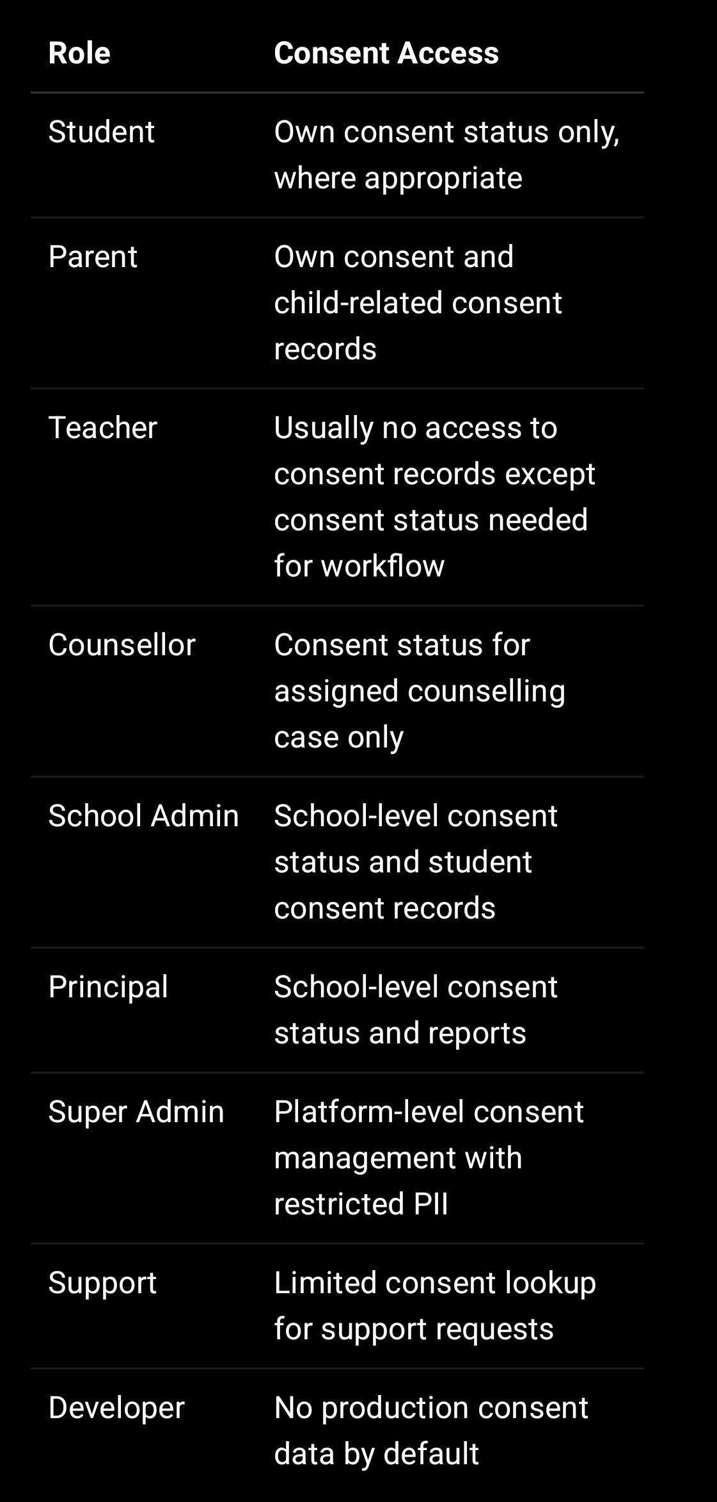

Access must follow authentication, role permission, school-level isolation, and object-level checks. Your access policy requires backend authentication, authorization, school-scope middleware, and object-level authorization for student/parent data.

—

17. Consent Audit Logging

Audit log should be created for:

Consent agreed
Consent withdrawn
Consent updated
Consent rejected
Consent verification failed
Parent/guardian OTP verified
School-authorised consent declaration accepted
AI consent granted
Document upload consent granted
Marketing opt-in/opt-out changed

Audit log fields:

{
requestId,
actorId,
actorRole,
schoolId,
module: "consents",
action,
result,
recordType: "Consent",
recordId,
ipAddress,
userAgent,
metadata: {
consentType,
consentVersion,
privacyPolicyVersion,
relatedRecordType,
relatedRecordId
},
createdAt
}

Do not log raw PII. Your secure logging guide warns that logs containing student academic records, parent contact details, counselling notes, passwords, tokens, Aadhaar, or cross-school data become compliance liabilities and breach vectors.

—

18. Consent Retention

Consent records should usually be retained as compliance proof.

Suggested retention:

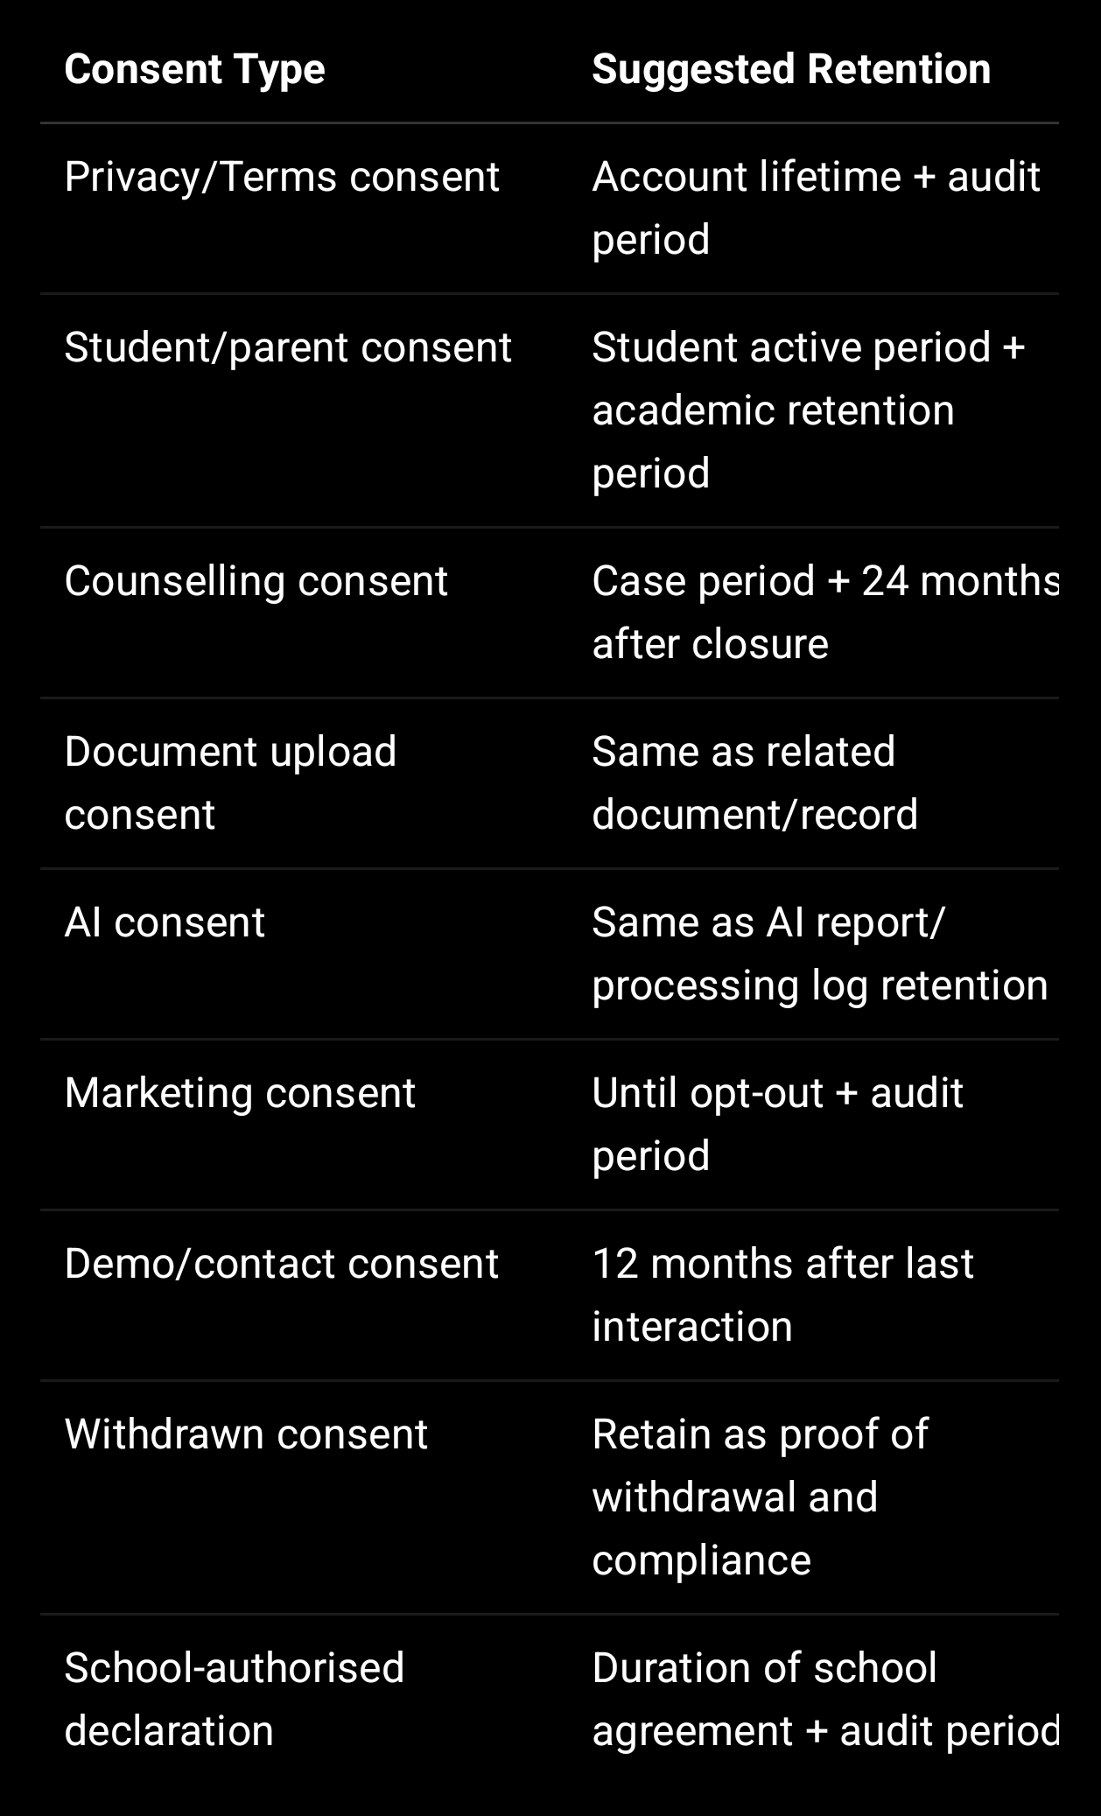
Your form guide recommends demo/contact retention periods such as draft for 30 days, submitted/active for 12 months after last interaction, and closed for 6 months then purge.

—

19. Consent Policy for Different Processing Situations

19.1 Mandatory Consent

Required for:

Student registration
Parent registration
Counselling
Document upload
AI-assisted analysis
Teacher profile
Mentor profile
Contact/demo form
Newsletter subscription

Your DPDP/security report lists these exact forms as requiring a consent checkbox.

19.2 Optional Consent

Should be optional:

Marketing/newsletter
Public photo/media use
Non-essential analytics/cookies
Third-party promotional communication

19.3 Consent Not Sufficient Alone

Even if consent exists, SproutSong should still apply:

Purpose limitation
Data minimisation
Access control
Security safeguards
Retention rules
Audit logs

Consent does not allow unlimited use of student data.

—

20. Compliance Tracking Fields

When this policy is published, store it in your compliance document collection.

{
documentType: "CONSENT_POLICY",
version: "v1.0",
title: "SproutSong / SproutMentors Consent Policy",
status: "PUBLISHED",
effectiveDate: "YYYY-MM-DD",
publishedUrl: "https://www.sproutsong.com/consent-policy",
approvedBy: "Management / Legal / Compliance",
approvedAt: "YYYY-MM-DDTHH:mm:ssZ",
linkedPrivacyPolicyVersion: "v1.0",
linkedTermsVersion: "v1.0",
linkedChildDataPolicyVersion: "v1.0",
changeSummary: "Initial published version",
createdAt: Date,
updatedAt: Date
}

—

21. Website Version — Short User-Facing Summary

Use this at the top of the published Consent Policy page.

SproutSong / SproutMentors collects consent before processing personal data where required.

For children’s data, we require parent/lawful guardian or school-authorised consent where applicable. Consent is collected through clear notices, unchecked checkboxes, declarations, OTP/email verification where needed, and school-authorised confirmations.

We store consent proof with timestamp, consent version, Privacy Policy version, user details, IP address, user agent, and related form/module details.

Users may request access, correction, withdrawal of consent, or deletion by contacting privacy@sproutsong.com.

—

22. Final Implementation Checklist

Before publishing and implementing this policy:

- Create consents collection.
- Create consent_templates collection.
- Add consent checkbox to all relevant forms.
- Make checkbox unchecked by default.
- Add Privacy Policy and Terms links near consent.
- Add parent/guardian consent for minors.
- Add OTP/email verification for sensitive child workflows.
- Add school-authorised consent declaration for school uploads/imports.
- Add separate AI consent.
- Add separate document upload consent.
- Add separate optional marketing/media consent.
- Store consent proof with timestamp, IP, user agent, consent version, and text hash.
- Add consentRefId to related records.
- Add audit log for consent creation/withdrawal.
- Add withdrawal request flow.
- Add privacy contact email on all forms.
- Mask PII in logs.
- Train internal team and school admins.
- Review annually or when policy changes.
- Publish and link this policy in footer, registration pages, counselling forms, AI forms, and document upload pages.

—

Final Internal Note

This Consent Policy should be published together with:

Terms & Conditions
Privacy Policy
Child Data Protection Policy
School Data Processing Agreement
Data Retention Policy
Breach Response Policy
AI Usage Disclaimer
Cookie Policy, if analytics/cookies are used

Your internal DPDP readiness guide already recommends a Consent Policy as part of the public documentation set for SproutSong.

